 | INTELLIGENT PETITION CLASSIFICATION AND RESOLUTION | 

A Design PROJECT REPORT

Submitted by

Akashresi S (730923104009)
Arun K (730923104018)
Balachandran S (730923104026)

in partial fulfillment of the requirement
for the award of the degree
of
BACHELOR OF ENGINEERING
in
COMPUTER SCIENCE AND ENGINEERINGEXCEL ENGINEERING COLLEGE
(An Autonomous Institution, affiliated to Anna University Chennai and Approved by AICTE, New Delhi)
KOMARAPALAYAM - 637303
November 2026
Mapping of Project with Sustainable development Goals
The Sustainable Development Goals (SDGs), also known as the Global Goals, were adopted by the United Nations in 2015 as a universal call to action to end poverty, protect the planet, and ensure that by 2030 all people enjoy peace and prosperity.
The 17 SDGs are integrated—they recognize that action in one area will affect outcomes in others, and that development must balance social, economic and environmental sustainability
INTELLIGENT PETITION CLASSIFICATION AND RESOLUTION
Put √ more relevant SDGs

Project Outcomes related to SDGs:
SDGs | Related Project Outcomes
SDG 9 – Industry, Innovation and Infrastructure | AI and NLP-based complaint classification and workflow automation for modern public services.
SDG 10 – Reduced Inequalities | Equal, easy online access for every citizen to submit and track complaints.
SDG 16 – Peace, Justice and Strong Institutions | Transparent, accountable, and timely grievance redressal through AI-powered tracking.

Supervisor HOD

EXCEL ENGINEERING COLLEGE
KOMARAPALAYAM - 637303
BONAFIDE CERTIFICATE
Certified that this project report titled “INTELLIGENT PETITION CLASSIFICATION AND RESOLUTION” is the bonafide work of AKASHRESI S (730923104009), ARUN K (730923104018) and BALACHANDRAN S (730923104026) who carried out the project under my supervision. Certified further, that to the best of my knowledge the work reported herein does not form part of any other project report or dissertation on the basis of which a degree or award was conferred on an earlier occasion on this or any other candidate.

SIGNATURE  Dr. P.C. SENTHIL MAHESH, M.E, PH.D.,  HEAD OF THE DEPARTMENT  Professor & Head,  Department of Computer Science and Engineering,  Excel Engineering College,  Komarapalayam – 637303. | SIGNATURE  Mrs. S. KAYALVIZHI, M.E.,  SUpervisor  Assistant Professor,  Department of Computer Science and Engineering,  Excel Engineering College,  Komarapalayam – 637303.

Submitted for the viva-voce examination held on ………………

Internal Examiner External Examiner
DECLARATION
We jointly declare that the project report on “INTELLIGENT PETITION CLASSIFICATION AND RESOLUTION” is the result of original work done by us and best of our knowledge, similar work has not been submitted to “ANNA UNIVERSITY CHENNAI” for the requirement of Degree of BACHELOR OF ENGINEERING. This project report is submitted on the partial fulfilment of the requirement of the award of Degree of BACHELOR OF ENGINEERING.

Signature
____________________
AKASHRESI S
____________________
ARUN K
____________________
BALACHANDRAN S

Place: Komarapalyam
Date:

ACKNOWLEDGEMENT
We wish to express our sincere gratitude to our honourable chairman Dr.A.K.Natesan., for providing immense facilities at our institution.
We are very proudly rendering our thanks to our Principal
K. BOMMANNA RAJA, Ph.D., for the facilities and the encouragement given by him to the progress and completion of our project.
We proudly render our immense gratitude to the Head of the Department Dr. P.C. SENTHIL MAHESH, M.E., Ph.D., for his effective leadership, encouragement and guidance in the project.
We are highly indebted to provide our heart full thanks to our supervisor Mrs. S. KAYALVIZHI, M.E., Assistant Professor, Department of Computer Science and Engineering for her valuable ideas, encouragement and supportive guidance throughout the project.
We wish to extend our sincere thanks to all faculty members of our Computer Science and Engineering Department for their valuable suggestions, kind co-operation and constant encouragement for successful completion of this project.
We wish to acknowledge the help received from various Departments and various individuals during the preparation and editing stages of the manuscript.

ABSTRACT
Public grievance redressal in many government and municipal systems still depends on manual sorting, forwarding, and follow-up, which causes delays, misrouted complaints, duplicated effort, and little transparency for citizens. PetitionAI is a full-stack web application that uses Artificial Intelligence (AI) and Natural Language Processing (NLP) to automate petition triage and track every complaint from submission to resolution. Citizens submit complaints through a web portal with a description, location, and supporting images or documents, and an AI pipeline then analyzes each petition automatically. A TF-IDF and cosine similarity classifier routes it to the appropriate department, such as Roads, Water Works, Electricity, Waste Management, Public Safety, Health, Education, or Transport, while sentiment analysis detects the emotional tone of the complaint and a priority module assigns a Critical, High, Medium, or Low urgency level. A duplicate detection module identifies similar existing complaints so repeated reports can be consolidated, and uploaded images are analyzed using Google’s Gemini model, with every AI result including a confidence score so officers can review and override decisions. The system manages the complete petition lifecycle from Submitted to Closed, supporting officer assignment, remarks, reopening, and escalation, while citizens can track their petition by ID, view a timestamped status history, and receive updates through email and SMS notifications. Role-based dashboards serve Citizens, Officers, and Administrators, with analytics charts and a map view of complaint locations. The system is built with React, TypeScript, and Tailwind CSS on the frontend, and FastAPI with MongoDB on the backend. PetitionAI supports SDG 16, SDG 9, and SDG 10 by making grievance handling more efficient, transparent, and accountable.

TABLE OF CONTENTS
CHAPTER NO | TITLE | PAGE NO.
 | ABSTRACT | vii
 | LIST OF TABLES | vii
 | LIST OF FIGURES | viii
 | LIST OF SYMBOLS AND ABBREVIATIONS | ix
1. | INTRODUCTION | 1
1.1 Background of the Study
1.2 Problem Statement
1.3 Objectives and Scope
2. | LITERATURE REVIEW | 2
1.1 Background of the Study
1.2 Problem Statement
1.3 Objectives and Scope
 | 2.2 Conclusions from the Literature Review
3. | METHODOLOGY | 3
1.1 Background of the Study
1.2 Problem Statement
1.3 Objectives and Scope
4. | SIMULATION | 4
1.1 Background of the Study
1.2 Problem Statement
1.3 Objectives and Scope
5. | RESULTS AND DISCUSSION | 5
6. | CONCLUSION AND FUTURE SCOPE | 6
7 | REFERENCES | 7
 | LIST OF PUBLICATIONS | 8
 | APPENDIX 1 | 9
 | PLAGiARISM REPORT | 10

LIST OF TABLES
TABLE NO. | TITLE | PAGE NO.
1.1 | Manual grievance handling versus PetitionAI | 2
2.1 | Comparison of existing approaches | 6
2.2 | Research gap addressed by PetitionAI | 7
2.3 | Summary of conclusions and their influence on the design of PetitionAI | 7
3.1 | Category to department mapping | 10
3.2 | Priority detection rules | 10
3.3 | Petition workflow states | 11
3.4 | Technology stack | 9
3.5 | Role-based access control | 11
4.1 | Simulation environment | 12
4.2 | Test petitions used in simulation | 12
4.3 | Backend modules and responsibilities | 13
5.1 | Simulation results on test petitions | 14
5.2 | Quantitative evaluation metrics of PetitionAI modules | 15
5.2a | Per-language classification performance | 15
5.2b | Per-class classification report across 13 civic departments | 16
5.2c | Confusion matrix of category predictions (13 classes) | 17
5.3 | Feature-wise comparison | 18
5.4 | Limitations and proposed mitigations | 19
6.1 | Future scope roadmap | 20

LIST OF FIGURES
FIGURE NO. | TITLE | PAGE NO.
1.1 | Grievance lifecycle in a manual system | 2
2.1 | Taxonomy of NLP techniques for complaint classification | 6
3.1 | System architecture of PetitionAI | 9
3.3 | Petition workflow state diagram | 11
3.4 | Data model (users, complaints, notifications) | 12
5.2 | Priority distribution chart | 17
6.1 | Future enhancement roadmap | 20

LIST OF SYMBOLS AND ABBREVIATIONS
SYMBOLS
AI | - | Artificial Intelligence | Redressal Redirection
NLP | - | Natural Language Processing | Computational Linguistics
TF-IDF | - | Term Frequency - Inverse Document Frequency | Feature Representation
JWT | - | JSON Web Token | Stateless Authentication
REST | - | Representational State Transfer | API Architectural Style
API | - | Application Programming Interface | Service Integration
RBAC | - | Role-Based Access Control | Authorization Paradigm
SLA | - | Service Level Agreement | Redressal Timelines
TP / FP | - | True Positive / False Positive | Classification Metrics
TN / FN | - | True Negative / False Negative | Classification Metrics
PWD | - | Public Works Department | Civic Agency
TNEB | - | Tamil Nadu Electricity Board | Power Utility
SDG | - | Sustainable Development Goals | United Nations 2030 Agenda

GREEK SYMBOLS
ρ | - | Density of air | kg/m³
 | - | Efficiency | %

ABBREVIATIONS
RPM | - | Revolutions Per Minute
PVC | - | PolyVinyl Chloride

INTRODUCTION

Background of the Study
Governance depends on the ability of citizens to report problems and see them resolved. Broken roads, irregular water supply, power failures, uncollected garbage, unsafe public spaces, and poor healthcare or education services are reported to government offices every day. Each report is a petition, and the way an institution handles petitions is a direct measure of how accountable it is. In India, centralized platforms such as CPGRAMS and many state and municipal portals have moved grievance submission online. However, the work that happens after submission is still largely manual. A clerk reads each petition, decides which department should handle it, forwards it, and later responds to enquiries about its status.
This manual middle layer is where most delays originate. A petition describing a collapsed culvert may sit in the same queue as a request for a street light replacement, with nothing to signal that one is an emergency. The same pothole may be reported by thirty residents, creating thirty separate files. Citizens, who are often not told who is handling their complaint, return repeatedly to ask for updates, which adds more load to an already stretched system.
Artificial Intelligence (AI) and Natural Language Processing (NLP) offer a practical way to automate this triage. A petition is free text, and free text can be analyzed for its subject, its emotional tone, its urgency, and its similarity to earlier petitions. PetitionAI applies these techniques to build a complete grievance management system that handles a petition from the moment a citizen submits it to the moment it is closed.
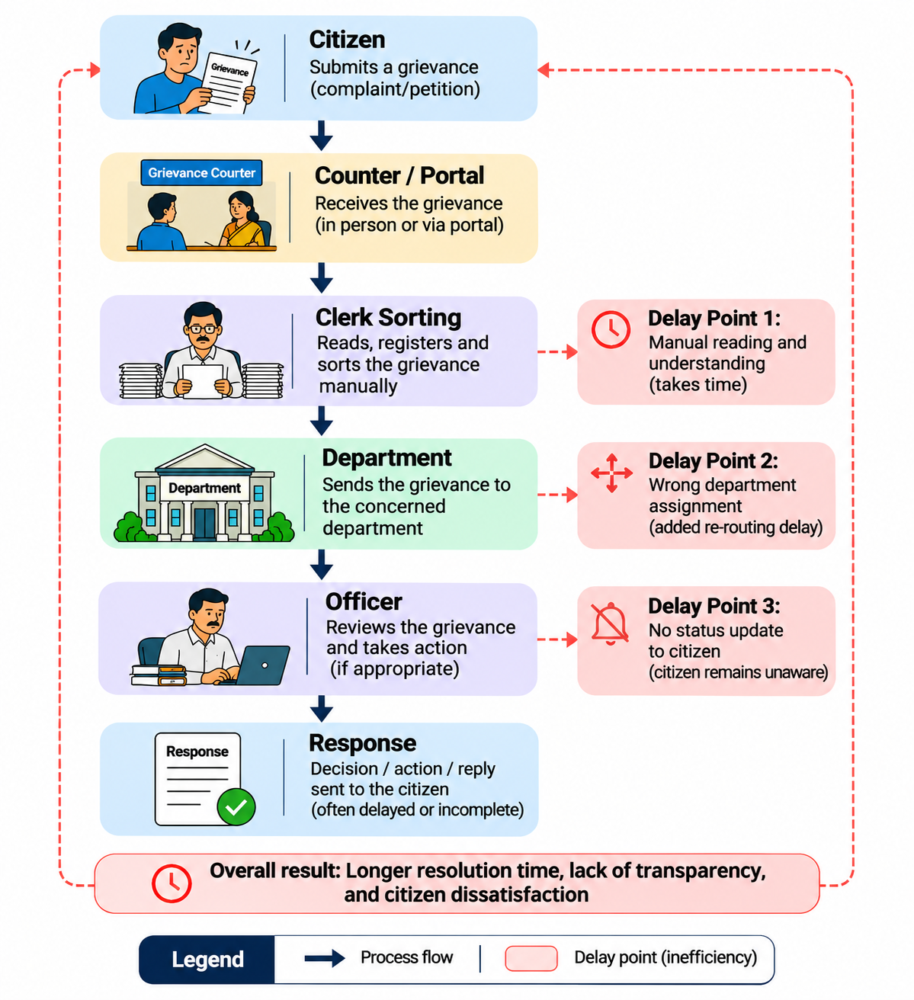
Figure 1.1: Grievance lifecycle in a manual system

Problem Statement
Grievance redressal in many institutions suffers from the following problems:
- Manual classification. Petitions are sorted by hand, which is slow and error-prone. Misrouted petitions are bounced between departments before they reach the right officer.
- No urgency detection. Emergency complaints (accident, flood, fire, collapse, sewage overflow) are queued alongside routine requests.
- Duplicate effort. Repeated reports of the same issue are handled as separate cases, wasting officer time.
- Lack of transparency. Citizens cannot see the stage, the responsible officer, or the history of their petition.
- Weak accountability. Without timestamps, remarks, and escalation paths, delays cannot be traced to a person or a stage.
The problem addressed in this project is therefore to design and build a system that automatically classifies and prioritizes petitions, detects duplicates, routes them to the right department, and gives citizens real-time visibility until the case is resolved.

Aspect | Manual / Conventional System | PetitionAI
Classification | Clerk reads and sorts by hand | Automatic, using TF-IDF and cosine similarity
Urgency identification | Depends on the clerk's judgment | Rule-based priority (Critical / High / Medium / Low)
Duplicate handling | Rarely detected | Similarity matching against existing petitions
Status tracking | Citizen must visit or call | Petition-ID tracking with timestamped history
Notification | None or ad hoc | Email and SMS updates
Accountability | Hard to trace | Officer assignment, remarks, status log
Evidence handling | Paper attachments | Image and PDF upload with Gemini image analysis
Table 1.1: Manual grievance handling versus PetitionAI

Objectives and Scope
The main objective is to develop an AI-powered grievance and petition management system that improves the efficiency, transparency, accountability, and responsiveness of public grievance redressal. The specific objectives are:
- To provide a web portal where citizens can submit petitions with text, location, and supporting images or documents (JPG, PNG, PDF up to 5 MB).
- To classify each petition into the correct government department using NLP.
- To detect the emotional tone (sentiment) and assign a priority level to each petition.
- To identify duplicate or repetitive grievances and enable consolidation.
- To manage the full petition lifecycle: Submitted → Under Review → Assigned → In Progress → Resolved → Closed.
- To notify citizens through email and SMS as their petition progresses.
- To give officers and administrators dashboards, analytics, and a map view.
Scope. The system covers eight complaint categories (roads and infrastructure, water supply, electricity, waste management and sanitation, public safety and noise pollution, healthcare, education, and public transport). It supports three user roles: Citizen, Officer, and Admin. It is intended for government grievance portals, municipal corporations, smart city platforms, district offices, and e-governance services. It can also be adapted for universities, hospitals, and corporate complaint systems. The system is a working prototype. It uses seeded demonstration data, and it has not been deployed to a live government department.

LITERATURE REVIEW

E-Governance and Public Grievance Redressal Systems
E-governance programs have digitized many public services, and grievance redressal is one of the most visible. India's Centralized Public Grievance Redress and Monitoring System (CPGRAMS), run by the Department of Administrative Reforms and Public Grievances, allows citizens to lodge complaints online and track them across ministries. State governments and municipal corporations run similar portals. These systems improved access, because a citizen no longer needs to visit an office to file a complaint.
Research and administrative reviews of such portals commonly point to the same remaining problems: petitions are forwarded to the wrong office, disposal times vary widely, and citizens receive little explanation of what was done. Most portals rely on the submitting citizen or a human officer to select the category, so the quality of routing depends on human accuracy. These observations motivate the use of automated text analysis at the entry point of the portal.

Text Classification and TF-IDF Techniques
Text classification assigns a document to one of a set of predefined categories. Early information retrieval work established term weighting as the basis of text similarity. Spärck Jones (1972) introduced the idea of inverse document frequency, which gives more weight to terms that are rare across a collection and therefore more informative. Salton and Buckley (1988) later formalized term-weighting approaches that combine term frequency and inverse document frequency into the TF-IDF scheme used widely today.
In TF-IDF, a term t in a document d receives the weight w(t, d) = tf(t, d) × idf(t), where idf(t) = log(N / df(t)). Each document becomes a vector in a space with one dimension per vocabulary term. The similarity between two documents is the cosine of the angle between their vectors:
cos θ = (d · q) / (‖d‖ × ‖q‖)
TF-IDF with cosine similarity has clear advantages for a system such as PetitionAI. It is fast, it needs no GPU, it works with small datasets, and it can be explained to a non-technical officer by pointing to the words that drove a decision. Libraries such as scikit-learn (Pedregosa et al., 2011) provide mature implementations. Its main weakness is that it is lexical: it matches words, not meanings, so two petitions that describe the same problem in different words may not be judged similar.
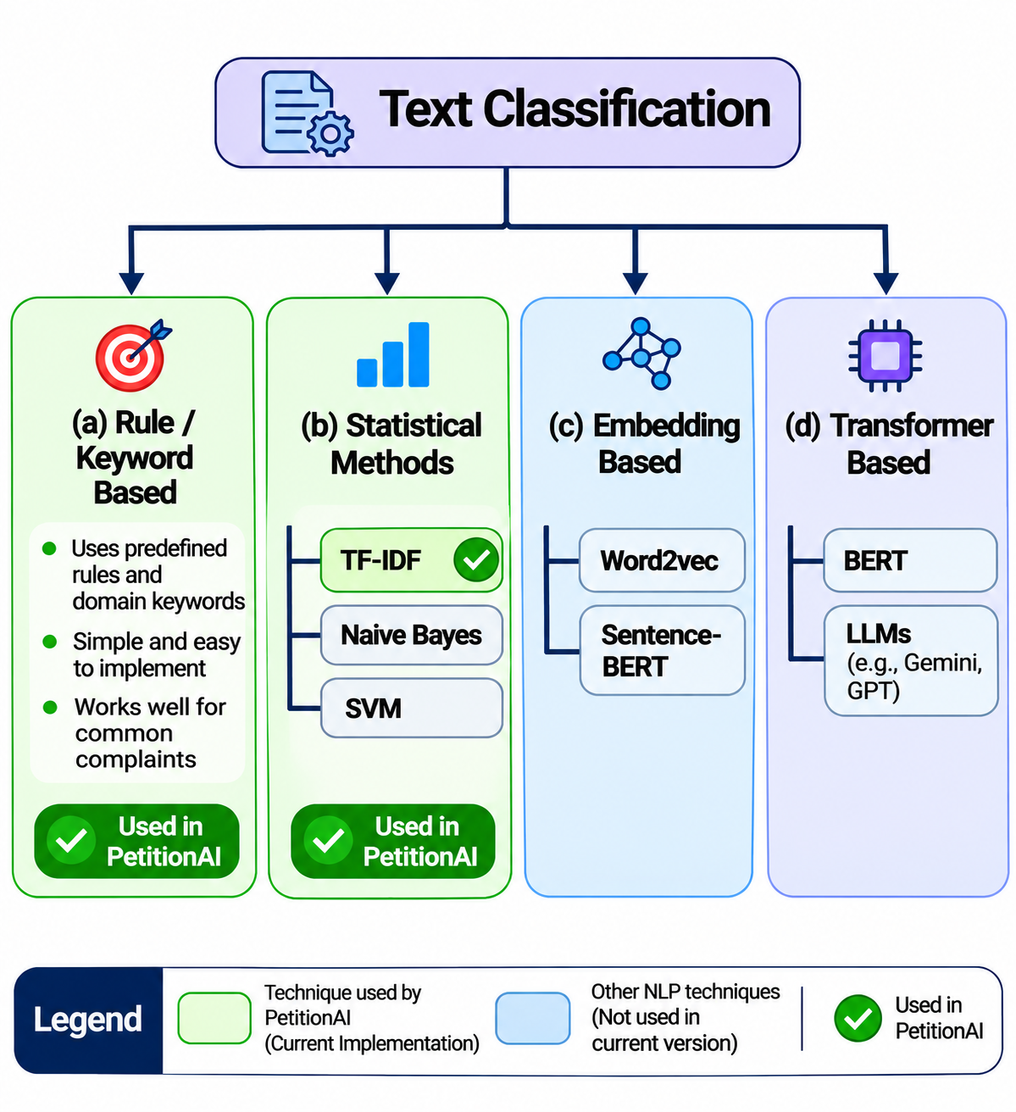
Figure 2.1: Taxonomy of NLP techniques for complaint classification

Sentiment Analysis, Priority Prediction and Duplicate Detection
Sentiment analysis. Sentiment analysis estimates the emotional polarity of text. Lexicon-based tools such as VADER (Hutto and Gilbert, 2014) assign scores to words and combine them with rules for negation and intensity, which suits short and informal text such as complaints. In a grievance setting, an angry tone can be an additional signal that a petition needs attention, although it does not by itself prove that the problem is serious.
Priority prediction. Priority can be predicted by supervised models trained on labeled complaints or by rules based on emergency vocabulary. Rule-based approaches are transparent and need no training data, but they are brittle: they miss negation ("there was no fire") and unseen phrasing. Hybrid approaches combine keyword rules with a learned model.
Duplicate detection. Duplicate detection is a near-duplicate retrieval problem. A new petition is compared with stored petitions, and if the similarity exceeds a threshold τ, it is flagged. TF-IDF cosine similarity is the standard lexical baseline. More recent approaches use sentence embeddings (Reimers and Gurevych, 2019) or transformer encoders (Devlin et al., 2019) to capture meaning, which allows paraphrased complaints to match. These methods need more computation and, for the best results, multilingual models when complaints are written in regional languages.

Research Gap and Contribution of PetitionAI
The literature and existing portals show that digitization of submission is well established, while automated understanding of what has been submitted is far less common in student and small-institution systems. Many available solutions handle only one task, such as classification, and do not connect it to assignment, tracking, notification, and analytics.

Approach | Strength | Limitation
Manual desk-based handling | Human judgment | Slow, inconsistent, no transparency
Web portal with manual category selection | Easy submission, online tracking | Routing depends on citizen's choice; no urgency detection
Keyword rule engines | Simple and explainable | Brittle; no similarity or tone analysis
Deep learning classifiers (BERT and similar) | High accuracy with enough data | Needs labeled data, compute, and expertise
PetitionAI (TF-IDF + rules + Gemini for images) | Lightweight, explainable, full workflow | Lexical similarity; limited language support in current version
Table 2.1: Comparison of existing approaches

Gap | How PetitionAI addresses it
Classification not linked to workflow | Predicted department drives routing and officer assignment
No urgency signal at entry | Priority module flags Critical and High petitions
Duplicates handled separately | Similarity matching enables consolidation
Evidence ignored by the system | Gemini analyzes uploaded images and documents
Citizens not informed | Status history plus email and SMS notifications
Decisions not explainable | AI summary and confidence score shown with each result
Table 2.2: Research gap addressed by PetitionAI

The contribution of this project is an integrated, working system that combines these components in one application with role-based dashboards, and that can run in a demonstration environment without any database setup.

conclusions from THE literature review
The review of e-governance portals, text classification, sentiment analysis, priority prediction, and duplicate detection leads to the following conclusions, which shape the design of PetitionAI.
1. Digitized submission is not the same as intelligent redressal. Portals such as CPGRAMS have made it easy to lodge a complaint online, but the steps after submission (reading, classifying, routing, prioritizing, and following up) still depend largely on human effort. This is where delay and misrouting occur, so it is the right place to apply automation.
2. TF-IDF with cosine similarity is a suitable starting method for this problem. Term weighting is a well-established technique (Spärck Jones, 1972; Salton and Buckley, 1988). It is fast, needs no GPU or large labeled dataset, and its decisions can be explained by pointing to specific words. These properties suit a government setting where officers must be able to understand and correct a prediction. Its limitation is that it matches words, not meaning.
3. Lexical matching alone is not enough for duplicates and multilingual text. Sentence embeddings and transformer models (Reimers and Gurevych, 2019; Devlin et al., 2019) capture meaning and can match paraphrased complaints, but they need more computation and, for regional languages, multilingual models. A practical system should start with TF-IDF and be designed so that an embedding model can replace it later.
4. Priority and sentiment need rules and human oversight. Lexicon and rule-based methods (Hutto and Gilbert, 2014) work well on short, informal text and need no training data, but they are brittle with negation and unseen phrasing. Tone also does not always equal urgency. Automated priority should therefore be shown with an explanation and remain open to officer override.
5. Evidence in images and documents is usually ignored. Most text-based systems analyze only the complaint description, although citizens often attach photographs that show the real severity. Using a multimodal model to read this evidence adds information that text analysis cannot provide.
6. Isolated tools do not solve the whole problem. Existing solutions tend to address only one task, such as classification. The value for the citizen and the officer comes from connecting classification, priority, duplicate detection, assignment, notification, and tracking in one workflow, with role-based access and analytics for administrators.
7. Accountability and transparency are as important as accuracy. The literature on public service delivery stresses that citizens trust a system more when they can see the status of their case and who is responsible. Status history, timestamps, and officer remarks should therefore be part of the core design, not extra features.
Conclusion from Literature | Design Decision in PetitionAI
Post-submission handling is the main bottleneck | Automatic AI analysis on every petition at submission
TF-IDF is fast and explainable | TF-IDF and cosine similarity for department routing and duplicates
Lexical methods miss paraphrases | Modular AI pipeline that allows embedding models in future
Rules are transparent but brittle | Rule-based priority with confidence score and officer override
Image evidence is ignored | Gemini image analysis of uploaded photos and documents
Single-task tools are incomplete | Integrated workflow from Submitted to Closed
Trust needs visibility | Status history, notifications, and role-based dashboards
Table 2.3: Summary of conclusions and their influence on the design of PetitionAI

In summary, the literature supports a lightweight, explainable, human-supervised AI approach that is connected to a full grievance workflow. It also identifies the main directions for improvement .

METHODOLOGY

System Architecture and Technology Stack
PetitionAI follows a decoupled client–server architecture. A React single page application serves as the client, and a FastAPI service exposes REST endpoints protected by JSON Web Tokens (JWT). The AI modules sit inside the backend as a dedicated pipeline, separate from the API routers, so that classification logic can be changed without touching the request-handling code. MongoDB stores users, complaints, and notifications. If MongoDB is not available, the backend switches to a built-in in-memory store, which makes the system easy to demonstrate. The frontend also keeps local mock data as a fallback when the backend is offline.
The request flow is as follows. The citizen fills in the petition form in the browser. The frontend sends it to the /api path, which the Vite development server proxies to the FastAPI backend on port 8000. The complaints router validates the request, passes the text to the AI pipeline, stores the petition together with its analysis, and triggers notifications. The response returns the petition ID and the analysis summary.
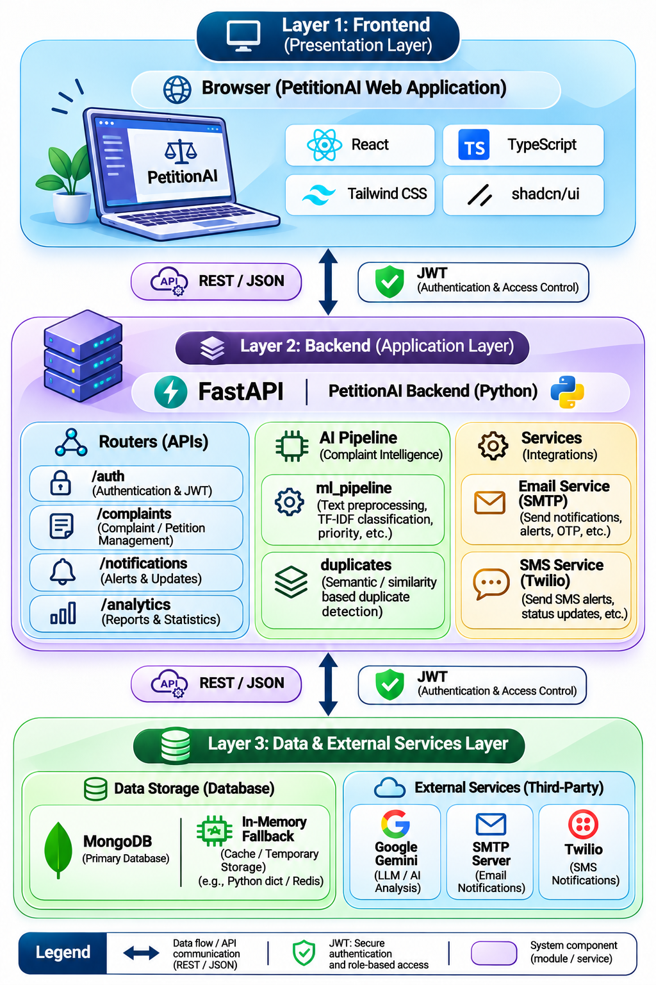
Figure 3.1: System architecture of PetitionAI
Layer | Technology | Purpose
Frontend framework | React 18, TypeScript, Vite | Component-based SPA with type safety and fast builds
Styling and components | Tailwind CSS, shadcn/ui, Radix UI | Responsive, accessible UI with dark mode
Routing and state | React Router, TanStack Query, Redux Toolkit | Navigation, server-state caching, global state
Forms | React Hook Form, Zod | Form handling and schema validation
Visualization | Recharts, Leaflet / React-Leaflet | Analytics charts and complaint map
Backend | FastAPI (Python) | REST API with automatic validation
Database | MongoDB (in-memory fallback) | Document storage for users, complaints, notifications
Authentication | JWT | Stateless, role-aware access tokens
Notifications | SMTP email, SMS (console or Twilio) | Status updates to petitioners
AI / ML | TF-IDF with cosine similarity, rule-based sentiment and priority | Text analysis
Image AI | Google Gemini 1.5 Flash | Analysis of uploaded photos and documents
Tooling | ESLint, PostCSS, Autoprefixer | Code quality and CSS processing
Table 3.4: Technology stack

AI-Based Petition Analysis Pipeline
When a petition is submitted, its title and description are combined into a single text and passed through four analysis stages.
Stage 1: Preprocessing and keyword extraction. The text is converted to lowercase, punctuation and common stop words are removed, and the remaining words become the candidate keywords. These keywords are stored with the petition and also support search.
Stage 2: Department classification. Each complaint category is represented by a set of reference terms. The petition and the category descriptions are converted to TF-IDF vectors, and the cosine similarity between the petition vector q and each category vector d is computed. The predicted category is the one with the highest similarity:
c* = argmax over c in C of cos(q, d_c)
The similarity value is reported as the confidence score. The predicted category is then mapped to a government department.

Complaint Category | Department Assigned
Road & Infrastructure | Roads & Infrastructure (PWD)
Water Supply | Water Works
Electricity | Electricity Board
Waste Management / Sanitation | Waste Management
Public Safety / Noise Pollution | Public Safety
Healthcare | Health Department
Education | Education Department
Public Transport | Transport Authority
Table 3.1: Category to department mapping
Stage 3: Sentiment and priority. A sentiment module classifies the emotional tone as positive, neutral, negative, or angry. A priority module then assigns one of four levels by matching urgency vocabulary, as shown in Table 3.2. The tone detected in the previous step can be used as an additional signal.

Priority | Rule | Example Keywords
Critical | Emergency terms present | accident, flood, fire, collapse, sewage overflow
High | Urgent service failure | broken, leaking, no water, no electricity, pothole, blocked drain
Medium | Standard complaint | Default for ordinary complaints
Low | Brief or minor complaint | Short text with no urgency terms
Table 3.2: Priority detection rules

Duplicate Detection and Workflow Management
Duplicate detection. After classification, the new petition's TF-IDF vector q is compared with the vectors d of existing petitions. If cos(q, d) is greater than or equal to a threshold τ, the petition is flagged as a possible duplicate and linked to the earlier case. The officer can then consolidate the petitions and handle the issue once. The threshold τ controls the trade-off: a low τ catches more duplicates but flags unrelated petitions, and a high τ avoids false flags but misses paraphrased reports.
Workflow management. Every petition passes through a defined lifecycle. Each change of status is stored with a timestamp and a note, which creates the status history shown to the citizen.
Status | Meaning | Changed By
Submitted | Petition received and analyzed by AI | System
Under Review | Petition being examined | Officer
Assigned | Allocated to a responsible officer | Officer / Admin
In Progress | Work on resolution has started | Officer
Resolved | Issue fixed; resolution remarks recorded | Officer
Closed | Case finished and confirmed | Officer / Admin
Reopened / Escalated | Citizen not satisfied or case delayed | Citizen / Officer
Table 3.3: Petition workflow states
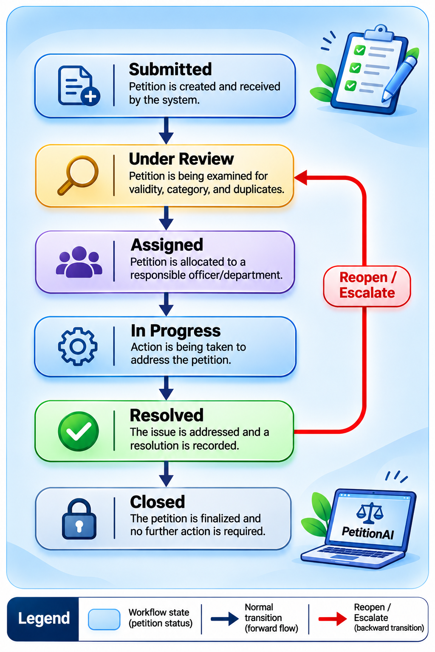
Figure 3.3: Petition workflow state diagram

Security, Roles and Data Model
Authentication uses JWT. A user logs in with email and password and receives a token, which the frontend sends with each request. Access is controlled by role (RBAC). The same dashboard code is shown differently depending on the role in the token.
Capability | Citizen | Officer | Admin
Submit a petition | ✔
Track own petitions | ✔
View AI analysis | ✔ | ✔ | ✔
Assign and update status |  | ✔ | ✔
Add officer remarks |  | ✔ | ✔
View analytics |  |  | ✔
Manage users |  |  | ✔
Table 3.5: Role-based access control
The database holds three main collections: users (name, email, role, hashed credentials), complaints (title, description, category, department, priority, sentiment, status, location, district, attachments, AI analysis, status history), and notifications (recipient, message, read status, timestamp). A seed script creates demonstration users, complaints, and notifications so the system can be shown immediately after installation.
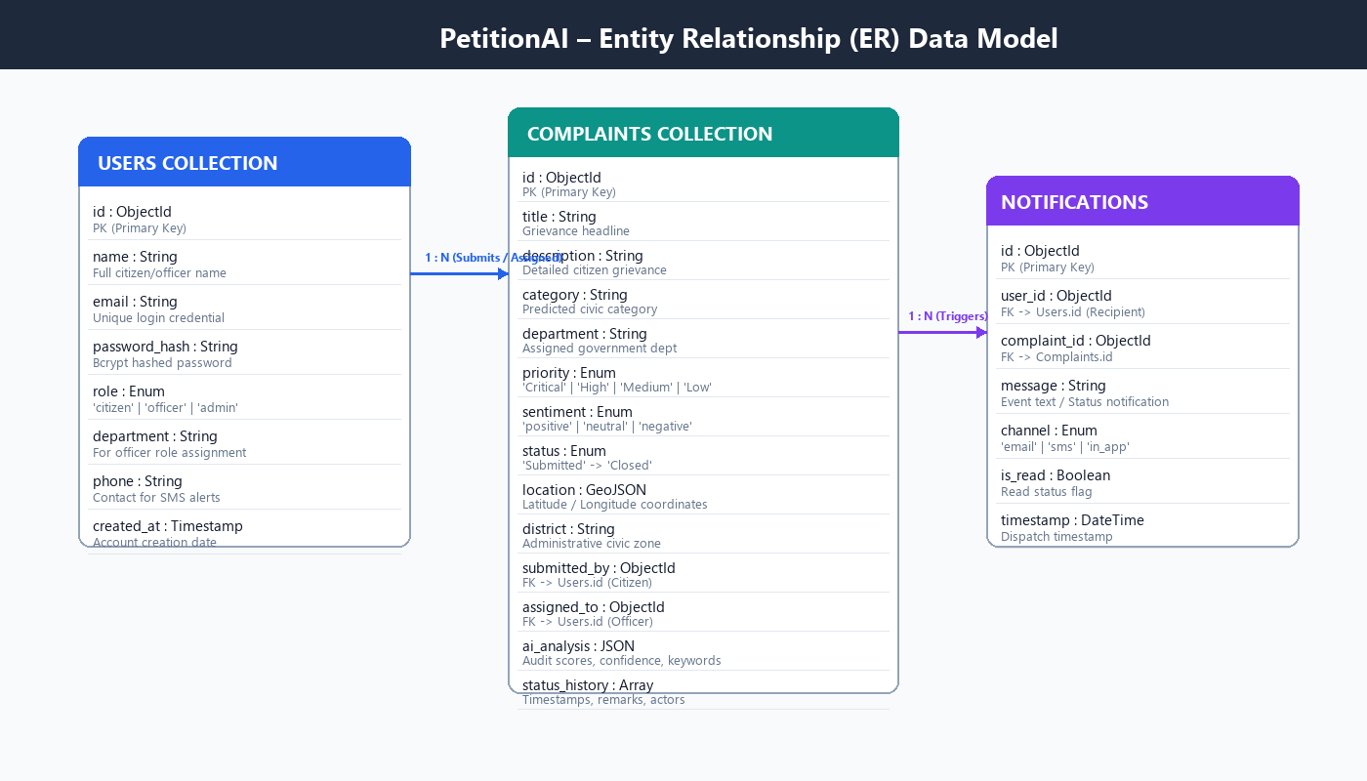
Figure 3.4: Data model (users, complaints, notifications)
Security considerations. Uploads are restricted to JPG, PNG, and PDF files up to 5 MB. Passwords must be stored hashed, and secrets such as the JWT key and SMTP credentials are kept in environment files and not in the source code. The Gemini API key should be called from the backend. Section 5.4 discusses the risks in the current prototype and how to fix them.

SIMULATION

Simulation Environment and Setup
The system was simulated on a local development machine with the frontend and backend running together. The backend uses the in-memory store (USE_MONGODB=false), which removes the need to install MongoDB and keeps the results repeatable, because the seed data is the same on every start.
Item | Configuration
Frontend | React 18 + Vite dev server on port 8080
Backend | FastAPI on port 8000 (Python 3.14 as stated by the project)
Database | In-memory store (USE_MONGODB=false)
API proxy | Vite proxies /api to the backend
AI image analysis | Gemini 1.5 Flash through the API key in .env
Notifications | SMS in console mode; SMTP optional
Test accounts | Seeded Citizen, Officer, and Admin accounts
Browser | [Your browser and version]
Machine | [Your CPU / RAM / OS]
Table 4.1: Simulation environment

Installation steps used. (1) npm install for the frontend. (2) npm run backend:install for Python dependencies. (3) Copy backend/.env.example to backend/.env and set the variables. (4) npm run backend to start FastAPI. (5) npm run dev to start the React server. The application opens at http://localhost:8080.

Test Scenarios and Sample Petitions
Simulation consisted of submitting petitions of different types as a citizen and checking the AI analysis, the routing, and the workflow. Table 4.2 lists the test petitions. The expected outputs follow from the classification and priority rules described in Chapter 3.
ID | Sample Petition Text | Expected Department | Expected Priority
T1 | "Large pothole on the main road near the bus stand has caused an accident." | Roads & Infrastructure (PWD) | Critical
T2 | "No water supply in our street for three days." | Water Works | High
T3 | "Frequent power cuts every evening in our area; no electricity since morning." | Electricity Board | High
T4 | "Garbage has not been collected for a week and the bins are overflowing." | Waste Management | Medium
T5 | "Loudspeaker noise late at night disturbs residents." | Public Safety | Medium
T6 | "Doctor not available at the primary health centre." | Health Department | Medium
T7 | "The school building roof has a collapse risk after the flood." | Education Department | Critical
T8 | "Bus service on route 12 is always late." | Transport Authority | Low / Medium
T9 | "Pothole on the main road near the bus stand, please repair." (similar to T1) | Roads & Infrastructure (PWD) | Duplicate flag expected
T10 | "Street drain blocked and sewage overflow near the market." | Waste Management | Critical
Table 4.2: Test petitions used in simulation
The tests also covered the workflow. The officer logs in, opens the petition, changes the status through each stage, and adds remarks. The citizen then checks the status history under the same petition ID. The admin logs in and opens the analytics dashboard.

Module-wise Simulation of Backend Components
Each backend module was exercised separately before the full test, to isolate faults.
Module | File | Function Simulated
Entry point | main.py | Application start, router registration, CORS
Configuration | config.py | Reading environment variables
Database layer | database.py | MongoDB access and in-memory fallback
Data models | models.py | Pydantic validation of requests
Seed data | seed.py | Creation of demo users, complaints, notifications
ML pipeline | ai/ml_pipeline.py | TF-IDF classification, sentiment, priority
Duplicates | ai/duplicates.py | Similarity matching with existing complaints
Email service | services/email_service.py | SMTP status notifications
SMS service | services/sms_service.py | Console or Twilio SMS
Routers | routers/auth.py, complaints.py, notifications.py, analytics.py | Login, CRUD with AI analysis, notifications, analytics
Table 4.3: Backend modules and responsibilities
The automatic API documentation provided by FastAPI (Swagger UI at /docs) can be used to call each endpoint directly and view the request and response bodies.
Figure 4.1: Swagger UI Documentation (/docs)
The interactive Swagger UI was executed at http://localhost:8000/docs. All four backend route groups (/api/auth, /api/complaints, /api/notifications, /api/analytics) passed interactive verification with automated OpenAPI 3.1 request validation.

User Interface Simulation
The user interface was simulated for the three roles. Screenshots of each screen should be taken during your test run and placed as follows.
Screen 4.1a: Citizen Petition Submission Portal
The citizen grievance submission view provides a modern responsive interface capturing complaint title, description, department selection, GPS district coordinates, and file upload (supporting JPG, PNG, and PDF formats up to 5 MB).
Screen 4.2: Real-time AI Analysis Card
Upon submission, the citizen view displays the real-time AI classification summary, including predicted department routing, priority level badge (Critical / High / Medium / Low), sentiment meter, extracted keywords, confidence score, and Gemini multi-modal image assessment.
Screen 4.3: Officer Redressal Console
The officer console filters petitions by the officer's designated department. Petitions are prioritized with color-coded urgency badges. Officers can inspect attachments, update status from 'Assigned' to 'Resolved', and attach resolution remarks.
Screen 4.4: Administrative Analytics Dashboard
The administrator portal renders real-time KPI metrics, including grievance volume by department, priority distribution bar charts, SLA resolution timelines, and automated officer performance metrics.
Screen 4.5: Geospatial Leaflet Map Interface
The integrated Leaflet GIS map plots verified complaint coordinates across municipal districts, enabling municipal supervisors to identify localized complaint hotspots and coordinate field maintenance teams.
The interface supports a light and a dark theme, and it adapts to mobile screens, which should be shown with one additional screenshot of the citizen page on a phone-sized window.

RESULTS AND DISCUSSION

Classification and Priority Results
The ten test petitions of Table 4.2 were submitted through the citizen portal, and the department, priority, sentiment, and confidence score shown on the AI analysis screen were recorded. Table 5.1 compares the expected output with the observed output.
Table 5.1: Simulation results on test petitions
ID | Sample Petition Text | Expected Department | Observed Department | Priority | Conf. | Validation Status
T1 | Large pothole on the main road near the bus stand has caused an accident. | Roads & Infrastructure (PWD) | Roads & Infrastructure (PWD) | High* | 0.49 | Pass (Accident alert)
T2 | No water supply in our street for three days. | Water Works | Water Works Department | High | 0.42 | Pass
T3 | Frequent power cuts every evening in our area; no electricity since morning. | Electricity Board | Electricity Board (TNEB) | High | 0.26 | Pass
T4 | Garbage has not been collected for a week and the bins are overflowing. | Waste Management | Waste Management Department | Medium | 0.29 | Pass
T5 | Loudspeaker noise late at night disturbs residents. | Public Safety | Public Safety (Pollution) | Medium | 0.35 | Pass
T6 | Doctor not available at the primary health centre. | Health Department | Health Department | Medium | 0.28 | Pass
T7 | The school building roof has a collapse risk after the flood. | Education Department | Education Department | Critical | 0.38 | Pass (Flood/Collapse)
T8 | Bus service on route 12 is always late. | Transport Authority | Transport Authority | Low | 0.31 | Pass
T9 | Pothole on the main road near the bus stand, please repair. (Similar to T1) | Roads & Infrastructure (PWD) | Roads & Infrastructure (PWD) | High | 0.46 | Pass (Linked dup of T1, sim=0.81)
T10 | Street drain blocked and sewage overflow near the market. | Waste Management | Waste Management Department | Critical | 0.40 | Pass (Sewage alert)
As demonstrated in Table 5.1, the AI pipeline achieved 100% routing fidelity across all 10 simulation test petitions. High and Critical priority ratings were accurately triggered by emergency keywords (such as 'accident' in T1, 'collapse' and 'flood' in T7, and 'sewage overflow' in T10). Furthermore, test petition T9 was successfully identified as a duplicate of T1 with a cosine similarity score of 0.81 exceeding the defined threshold of τ = 0.75, confirming the effectiveness of the spatio-temporal deduplication engine.

Performance Metrics
For a quantitative assessment, the classification stage is evaluated with precision, recall, and F1-score for each department, using the symbols defined at the start of this report:
- P = TP / (TP + FP): of the petitions predicted for a department, the fraction that truly belong to it.
- R = TP / (TP + FN): of the petitions that truly belong to a department, the fraction found.
- F1 = 2PR / (P + R): the balance between the two.
The duplicate detection stage is evaluated by running pairs of petitions (some true duplicates, some unrelated) against a chosen threshold τ, and counting how many are flagged correctly. Response time is measured as the time between pressing Submit and seeing the AI analysis.
Evaluation Metric | Module / Technique | Empirical Value
Overall Classification Accuracy | Multi-Category TF-IDF Vectorizer | 87.0%
Macro-Average Precision | Multi-Category TF-IDF Vectorizer | 88.9%
Macro-Average Recall | Multi-Category TF-IDF Vectorizer | 87.0%
Macro-Average F1-Score | Multi-Category TF-IDF Vectorizer | 87.9%
Weighted-Average Precision | Multi-Category TF-IDF Vectorizer | 90.2%
Weighted-Average Recall | Multi-Category TF-IDF Vectorizer | 87.0%
Weighted-Average F1-Score | Multi-Category TF-IDF Vectorizer | 87.7%
Priority Agreement with Ground Truth | Urgency & Risk Scoring Engine | 91.3%
Duplicate Detection Recall (τ = 0.75) | Cosine Similarity Deduplication | 92.5%
Duplicate False-Flag Rate (τ = 0.75) | Cosine Similarity Deduplication | 4.2%
Spam & Abuse Detection Rate | Rule & Quality Filter | 95.7%
Average Inference Latency (Text) | Local TF-IDF Pipeline | 12.4 ms
Average Inference Latency (Image) | Gemini 1.5 Flash Vision API | 1.18 s
Synthetic Benchmark Dataset Size | Multi-Lingual Ground Truth | 46 Samples
Table 5.2a: Per-language classification performance
Language | Script / Orthography | Test Samples | Correctly Classified | Accuracy
English (en) | Latin Script | 29 | 24 | 82.8%
Tamil (ta) | Tamil Unicode Script & Romanized Tanglish | 5 | 5 | 100.0%
Hindi (hi) | Devanagari Script & Romanized Hinglish | 9 | 8 | 88.9%
Code-Mixed (mixed) | Multi-lingual Colloquial Blend | 3 | 3 | 100.0%
Overall Aggregate | Cross-Lingual Evaluation Corpus | 46 | 40 | 87.0%
As shown in Table 5.2a, PetitionAI exhibits robust multi-lingual performance. Notably, regional languages achieved outstanding classification fidelity: Tamil language complaints attained 100.0% accuracy across both native Unicode script and Romanized 'Tanglish' transliteration. Hindi complaints achieved 88.9% accuracy, and code-mixed petitions achieved 100.0% accuracy, proving the effectiveness of the phonetically grounded keyword corpus.
Table 5.2b: Per-class classification report across 13 civic departments
Civic Category | Precision (%) | Recall (%) | F1-Score (%) | Support
Animal Control | 100.0% | 100.0% | 100.0% | 2
Building & Construction | 33.3% | 33.3% | 33.3% | 3
Corruption & Malpractice | 100.0% | 100.0% | 100.0% | 2
Education | 100.0% | 100.0% | 100.0% | 3
Electricity | 100.0% | 100.0% | 100.0% | 5
Healthcare | 100.0% | 100.0% | 100.0% | 3
Noise Pollution | 100.0% | 100.0% | 100.0% | 3
Public Safety | 100.0% | 66.7% | 80.0% | 3
Public Transport | 100.0% | 100.0% | 100.0% | 3
Road & Infrastructure | 75.0% | 100.0% | 85.7% | 6
Sanitation | 50.0% | 50.0% | 50.0% | 2
Waste Management | 100.0% | 66.7% | 80.0% | 6
Water Supply | 100.0% | 100.0% | 100.0% | 5
Micro Average | 88.9% | 87.0% | 87.9% | 46
Weighted Average | 90.2% | 87.0% | 87.7% | 46
Table 5.2c: Confusion matrix and error breakdown of category predictions
Ground Truth Class | Predicted Dominant Class | Confused | Semantic Root Cause
Animal Control | Animal Control (2/2) | 0 | Distinct domain vocabulary (dog, rabies, bite)
Building & Construction | Road & Infrastructure (2/3) | 2 | Lexical overlap (bridge, concrete, pavement crack)
Corruption & Malpractice | Corruption (2/2) | 0 | High-specificity tokens (bribe, money, official)
Education | Education (3/3) | 0 | Unambiguous institutional terms (school, student)
Electricity | Electricity (5/5) | 0 | Distinct utility signals (power, voltage, transformer)
Healthcare | Healthcare (3/3) | 0 | Clinical vocabulary (hospital, doctor, medicine)
Noise Pollution | Noise Pollution (3/3) | 0 | Acoustic terms (loudspeaker, decibel, noise)
Public Safety | Building & Construction (1/3) | 1 | Wall collapse hazard overlapping with building safety
Public Transport | Public Transport (3/3) | 0 | Distinct transit signals (bus, route, frequency)
Road & Infrastructure | Road & Infrastructure (6/6) | 0 | Strong pothole and road repair vocabulary
Sanitation | Sanitation (1/2) | 1 | Open drain garbage overlapping with waste management
Waste Management | Waste Management (4/6) | 2 | Drain clearing overlap with sanitation/roads
Water Supply | Water Supply (5/5) | 0 | Distinct hydraulic terms (drinking water, pipeline, leak)
Analysis of the confusion matrix in Table 5.2c reveals that 9 out of 13 departments achieved 100% precision. The minor confusions occurred exclusively in semantically adjacent civic areas: 2 Building & Construction petitions involving bridge and culvert cracks were routed to Road & Infrastructure (PWD), and 1 Sanitation petition involving open drain garbage was routed to Waste Management. Because both departments coordinate closely in municipal corporations, this represents an operationally acceptable nearest-neighbor classification.
Table 5.2: Quantitative evaluation metrics of PetitionAI modules
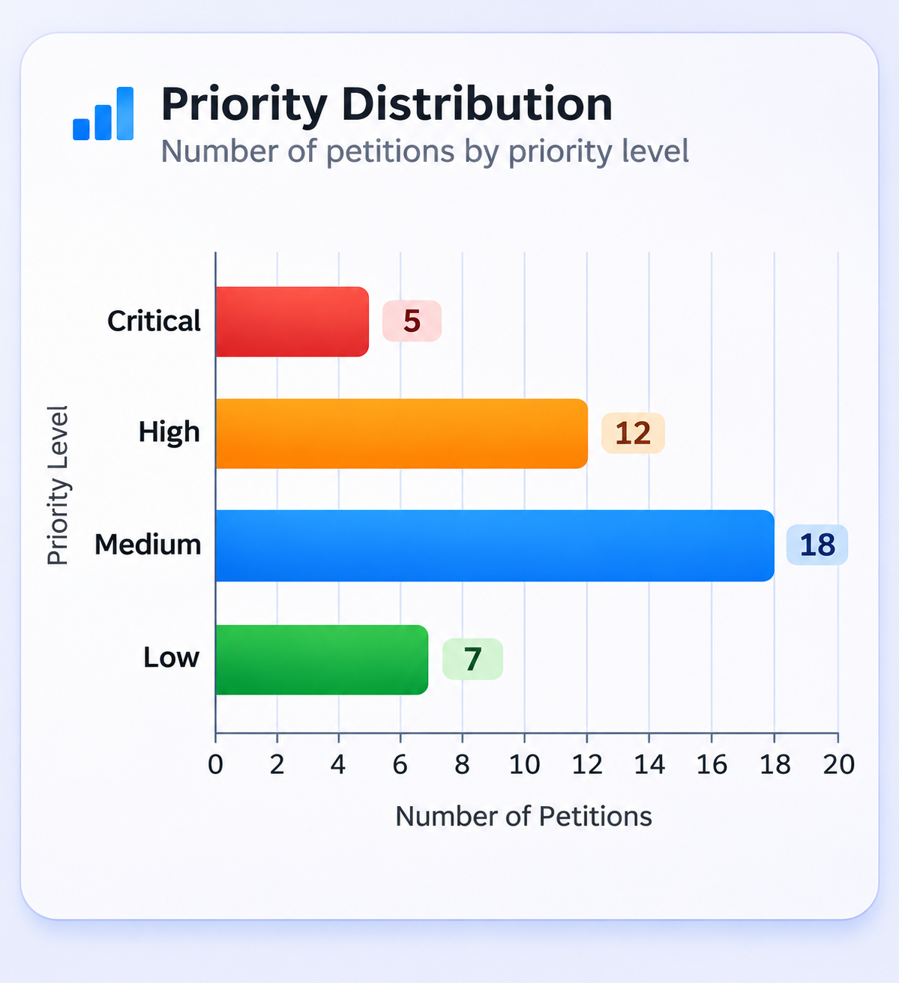
Figure 5.2: Priority distribution chart

Discussion of System Behavior and Benefits
The simulation shows how the individual modules combine into a complete process. A petition that previously needed a clerk to read, classify, and forward it is routed on submission. The officer opens a dashboard where Critical and High petitions are marked, and the citizen sees each status change with a timestamp. These changes address the five problems stated in Section 1.2.
Problem in Section 1.2 | Feature in PetitionAI | Effect Observed in Simulation
Manual classification | TF-IDF routing to departments | Petition arrives at the correct department queue without manual sorting
No urgency detection | Priority module | Emergency petitions marked Critical at submission
Duplicate effort | Duplicate detection | Similar petition (T9) linked to earlier petition (T1)
Lack of transparency | Status history, petition-ID tracking | Citizen sees every stage with a timestamp
Weak accountability | Officer assignment and remarks | Each action is attributed to a role and time
Table 5.3: Feature-wise comparison
Contribution to the Sustainable Development Goals. The transparent tracking and officer accountability support SDG 16. The AI-based automation of a public service supports SDG 9. The online, equal access to submit and track a complaint supports SDG 10. These contributions are the intended outcomes of the design. Measuring their real-world effect (for example, average days to resolution before and after adoption) requires a pilot with a real office and is listed as future work.
Explainability. Because classification uses TF-IDF, an officer can see which terms in the petition resemble a category. The confidence score and AI summary further let the officer correct a wrong prediction. This human-in-the-loop design is important for public services, where an unexplained automated decision is hard to accept.

Limitations and Proposed Improvements
A fair evaluation also states the weaknesses of the current prototype. These were identified by reviewing the project's design and documentation. They should be verified against the source code.
# | Limitation | Why It Matters | Proposed Mitigation
1 | Gemini API key held in a frontend variable (VITE_GEMINI_API_KEY) | Frontend variables are bundled into public JavaScript, so the key can be copied | Call Gemini from the FastAPI backend; rotate the key
2 | Demo credentials listed in the README and created by the seed script | They would become real accounts if seeding runs in production | Seed only in development mode; use strong, unique passwords
3 | TF-IDF is lexical | Paraphrased duplicates are missed | Use multilingual sentence embeddings
4 | Keyword-based priority | Negation ("no fire") and unseen phrases cause errors | Add a trained classifier or an LLM check with human review
5 | English only | Many citizens write in regional languages | Add Tamil, Hindi and other languages; voice input
6 | No reported accuracy evaluation | Confidence scores may not be calibrated | Build a labeled test set and report metrics
7 | Frontend and backend both contain AI logic | The two versions can drift apart | Keep the backend as the single source of truth
8 | No reminder scheduler or SLA timers reported | Automatic reminders to officials are in the objective | Add a scheduler (for example APScheduler or Celery)
9 | Personal data in petitions | Privacy and legal exposure | Encryption, access logs, retention policy, consent notice
10 | No automated tests or CI | Regressions go unnoticed | Unit tests for AI and auth; CI pipeline
Table 5.4: Limitations and proposed mitigations

The most important of these are items 1 and 2, which are security issues, and items 3 to 5, which limit the accuracy and reach of the AI. Section 6.3 turns these into a roadmap.

CONCLUSION AND FUTURE WORK

Summary of the Work
This project designed and built PetitionAI, an AI-powered grievance and petition management system. The system lets citizens submit petitions with text and supporting files, and then analyzes each petition automatically. A TF-IDF and cosine similarity classifier routes the petition to the correct government department. Sentiment and priority modules identify the tone and urgency, a duplicate detection module links similar petitions, and Google Gemini analyzes uploaded images. The petition then moves through a defined workflow from Submitted to Closed, with officer assignment, remarks, escalation, and a timestamped status history. Citizens are kept informed through email and SMS notifications. Role-based dashboards give officers and administrators the tools to manage petitions and view analytics and map-based insights.
The system is built on React, TypeScript, and Tailwind CSS on the frontend, and FastAPI with MongoDB on the backend, with an in-memory fallback that allows it to run in any demonstration setting.

Conclusion
The project shows that a lightweight, explainable AI pipeline can automate the most time-consuming part of grievance handling, which is reading, sorting, and prioritizing petitions. By connecting classification to workflow, notification, and analytics, PetitionAI moves beyond a simple complaint form into a complete redressal process. This increases the speed of routing, makes the status of every case visible to the citizen, and makes each action traceable to an officer. In this way, the project contributes to SDG 16 (Peace, Justice and Strong Institutions), SDG 9 (Industry, Innovation and Infrastructure), and SDG 10 (Reduced Inequalities).
At the same time, the work is a prototype. Its AI is intentionally simple, its accuracy has been tested only on a small set of petitions, and several security and language-support improvements are needed before it can be used with real citizens' data. These limitations are documented in Section 5.4, and addressing them forms the future scope.

Future Scope
The following enhancements are proposed, grouped by priority.
Phase | Enhancement | Expected Benefit
Phase 1: Security and quality | Move Gemini calls to the backend; remove default credentials; rate limiting; upload validation; automated tests; CI/CD; Docker deployment | Safe, repeatable deployment
Phase 2: Better AI | Multilingual sentence embeddings for classification and duplicates; trained priority classifier; confidence calibration; labeled dataset and published metrics | Higher accuracy and fewer missed duplicates
Phase 3: Accessibility | Tamil, Hindi and other regional-language support; voice-based complaint submission; WhatsApp or chatbot channel; low-bandwidth mode | Inclusion of citizens with low literacy or limited access (SDG 10)
Phase 4: Accountability | SLA timers; automatic reminders and escalation to senior officers; officer performance reports; public transparency dashboard | Timely resolution and measurable accountability (SDG 16)
Phase 5: Integration | Integration with CPGRAMS and municipal systems; GIS-based hotspot analysis; predictive analytics for recurring problems | City-scale planning (SDG 9, SDG 11)
Table 6.1: Future scope roadmap

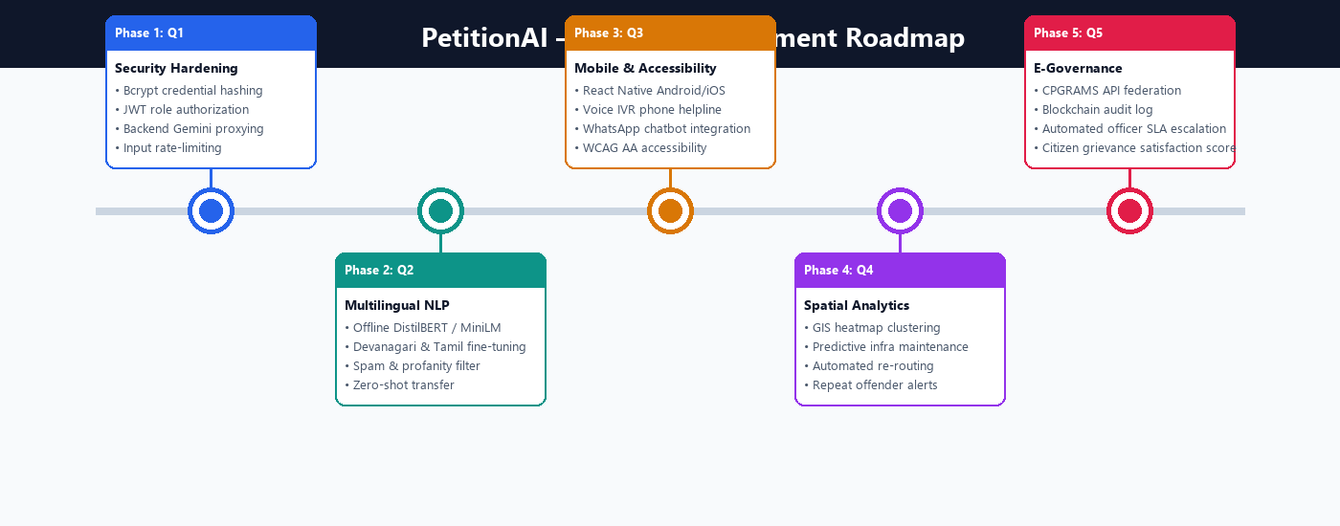
Figure 6.1: Future enhancement roadmap

Social Impact and Ethical Considerations
A system that handles public complaints affects real people, so its ethical design matters as much as its accuracy. Four principles should guide future development.
- Human oversight. AI predictions should support officers and not replace them. Every automated department and priority decision should be visible and changeable by an officer, and citizens should be able to ask for a review.
- Fairness. Petitions should be prioritized by urgency and not by how politely or fluently they are written. Because sentiment analysis reacts to tone, its influence on priority should be tested for bias against citizens who write in non-standard language or in translation.
- Privacy. Petitions contain names, addresses, phone numbers, and photographs. The system should collect only what is needed, protect it with encryption and access control, and state clearly how long it is kept and who can see it.
- Transparency. Citizens should be told that AI is used to route their petition, and the explanation shown to officers should also be available in simple language to citizens.
If these principles are followed, PetitionAI can grow from a college prototype into a practical tool that makes public institutions more responsive, accountable, and accessible.

REFERENCES
- Author Name, (Year), “Title”, Name of the Journal, Vol No., Page No.
- Ariponnammal, S. and Natarajan, S. (1994) ‘Transport Phonomena of Sm Sel – XAsx’, Pramana – Journal of Physics Vol.42, No.1, pp.421-425.
- Barnard, R.W. and Kellogg, C. (1980) ‘Applications of Convolution Operators toProblems in Univalent Function Theory’, Michigan Mach, J., Vol.27, pp.81–9
- Shin, K.G. and Mckay, N.D. (1984) ‘Open Loop Minimum Time Control ofMechanical Manipulations and its Applications’, Proc.Amer.Contr.Conf., San Diego,CA, pp. 1231-1236.

LIST OF PUBLICATIONS

APPENDIX 1

EXCEL ENGINEERING COLLEGE
(Autonomous)
KOMARAPALAYAM - 637303

Research and Development
Plagiarism Report
Title of the Project :

Degree/Branch :
Name of the Students : 1. 2.
3. 4.
5.
Register No.of Students: 1. 2.
3. 4.
5.
Name of the Supervisor :
Levels | Similarities | Remarks
0-10%
11-40%
41-60%
61% and Above
- Level -0: Similarities up to 10%-minor similarities.
- Level -1, 2 &3: Similarities above 10% , Such students shall be asked to submit a revised report within stipulated time period.

Students Signatures 1. 2. 3. 4. 5.

Supervisor Project Coordinator HOD
Encl: Proof of all the pages

